**Technology Architecture**

|  |  |
| --- | --- |
| Date | 15 October 2022 |
| Team ID | PNT2022TMID12612 |
| Project Name | Signs with Smart Connectivity for Better Road Safety |
| Maximum Marks | 4 Marks |

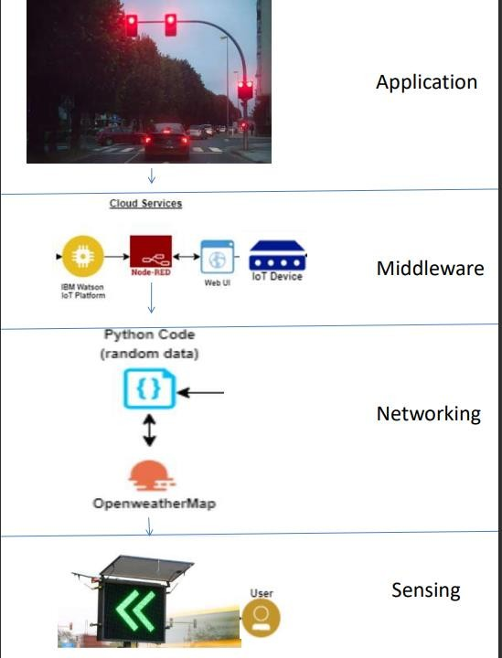

**GUIDELINES:**

* To replace the static signboards, smart connected sign boards are used.
* These smart connected sign boards get the speed limitations from a web app using weather API and update automatically.
* Based on the weather changes the speed may increase or decrease.
* Based on the traffic and fatal situations the diversion signs are displayed.
* Guide(Schools), Warning and Service(Hospitals, Restaurant) signs are also displayed accordingly.
* Different modes of operations can be selected with the help of buttons.

**Table-1: Application Characteristic**

|  |  |  |  |
| --- | --- | --- | --- |
| **S.No** | **Component** | **Description** | **Technology** |
| 1. | User Interface | How user interacts with application e.g.  Web UI, Mobile App. | HTML, CSS, JavaScript / Angular Js / React Js etc. |
| 2. | Application Logic-2 | Logic for a process in the application | IBM Watson STT service |
| 3. | Application Logic-3 | Logic for a process in the application | IBM Watson Assistant |
| 4. | Cloud Database | Database Service on Cloud | IBM DB2, IBM Cloud. |
| 5. | External API-1 | Purpose of External API used  in the application | IBM Weather API, etc. |

**Table-2: Application Characteristic:**

|  |  |  |  |
| --- | --- | --- | --- |
| **S.No** | **Characteristics** | **Description** | **Technology** |
| 1. | Security Implementations | Strong security system that anyone without login credentials and hackers are not allowed to enter  the network. | Firewall, Firebase, Cyber resiliency strategy |
| 2. | Scalable Architecture | Easy to expand the operating range by increasing the bandwidth of the network. | IOT, internet. |
| 3. | Availability | Available anytime and everywhere 24/7 as long as the user is signed into the network. | IBM Cloud |
| 4. | Performance | Supports a large number of users to  access the technology simultaneously. | IBM cloud |